**Thirteen Companies That Use Deep Learning To Produce Actionable ResultsKevin Murnane**#NewTechDeep learning networks open up the treasure chest of unstructured data

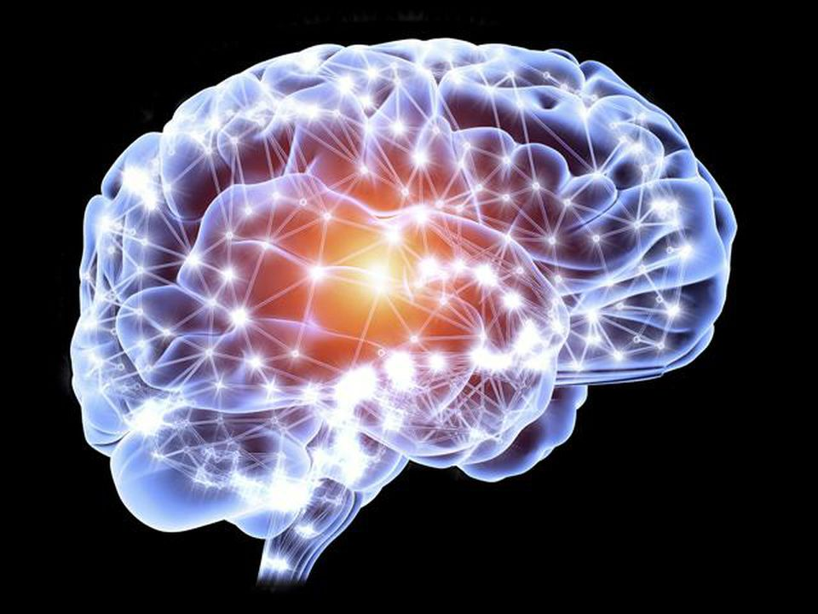

Credit: Getty

Our means for gathering data have largely outstripped our tools for analyzing that data. The result is a mountain of unstructured and largely inaccessible information gathered from social media, app permissions, website cookies and hardware and software service agreements. There's gold in that mountain, but you need the right tools to get at it. For many applications, deep learning is the right tool. [Deep learning networks open up the treasure chest of unstructured data](https://twitter.com/intent/tweet?url=http%3A%2F%2Fwww.forbes.com%2Fsites%2Fkevinmurnane%2F2016%2F04%2F01%2Fthirteen-companies-that-use-deep-learning-to-produce-actionable-results%2F&text=Deep%20learning%20networks%20open%20up%20the%20treasure%20chest%20of%20unstructured%20data) for anyone with the imagination to draw insight from new sources of knowledge discovery, knowledge application, and knowledge-based prediction.

If you are unfamiliar with deep learning, the article "[What Is Deep Learning And How Is It Useful?](http://www.forbes.com/sites/kevinmurnane/2016/04/01/what-is-deep-learning-and-how-is-it-useful/#2aafc63d10f0)" will give you the basic information you need.

It wasn't long ago that you had to have machine learning experts on staff to design and build deep learning networks that could produce actionable results. Those days are over. Nowadays there are many companies that provide deep learning solutions across a wide range of applications. Here are 13 of them.

[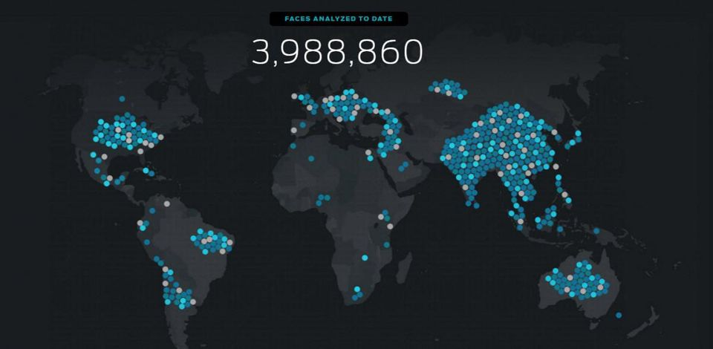](http://www.affectiva.com/)

Affectiva, used by permission

[Affectiva](http://www.affectiva.com/) is an MIT Media Lab spinoff that uses deep learning networks to identify emotions from video or still images. Their software runs on [Microsoft](https://www.forbes.com/companies/microsoft/) [**MSFT +0.62%**](https://www.forbes.com/companies/microsoft/) Windows, Android and iOS and works with both desktop and mobile platforms. Applications include real-time analysis of emotional engagement with broadcast or digital content, video games that respond to the player's emotions, and offline integration with a range of biosensors for use in research or commercial environments.

**MORE FROM FORBES**

Cox*Voice:***When You Feel Like Throwing Your Business Phone At The Wall, Blame Physics Instead**

NVIDIA*Voice:***Why Did NVIDIA Build The World's Largest GPU?**

Cox*Voice:***When You Feel Like Throwing Your Business Phone At The Wall, Blame Physics Instead**

[Gridspace](https://www.gridspace.com/) uses deep learning networks to drive sophisticated speech recognition systems. Their networks begin with raw audio and build up to topic, keyword and speaker identification. Their Gridspace Memo software is designed to identify speakers, keywords, critical moments, and time-spent-talking, along with providing group take-aways from conference calls. Gridspace Sift provides similar information about customer service and contact calls.

[Ditto Labs](http://ditto.us.com/) has built a detection system that uses deep learning networks to identify company brands and logos in photos posted to social media. Their software also identifies the environment in which brands appear and whether a brand is accompanied by a smiling face in the photo. Clients can use Ditto to track brand presence at events or locations, compare brand performance with competitors, and target advertising campaigns.

[Nervana](http://www.nervanasys.com/)provides a deep learning framework called neon that allows users to build their own use-case deep learning networks. They also provide a deep-learning cloud service where users can import and analyze their data using one of Nervana's deep learning models or a model of their own design that uses neon. They suggest solutions in the areas of finance, energy and online services among others.

[Deep Genomics](http://www.deepgenomics.com/) uses deep learning networks to predict how both natural and therapeutic genetic variation changes cellular process such as DNA-to-RNA transcription, gene splicing, and RNA polyadenylation. Applications include better understanding of diseases, disease mutations and genetic therapies. Spidex, their first product, provides "a comprehensive set of genetic variants and their predicted effects on human splicing across the entire genome. "

[Indico](https://indico.io/)builds text and image analysis tools using deep learning networks. Their text analysis application works in real time as you type and identifies positive/negative and political sentiment, topics and keywords. It also predicts [Twitter](https://www.forbes.com/companies/twitter/) [**TWTR -0.25%**](https://www.forbes.com/companies/twitter/) engagement. Their image analysis software locates faces, identifies facial emotions, filters for NSFW images and more. Suggested applications include brand equity analysis, product recommendation, and identifying clothing similarity.

[](http://www.deepinstinct.com/#/what-we-offer)

Credit: Deep Instinct, used by permission

[Deep Instinct](http://www.deepinstinct.com/#/what-we-offer) is a cybersecurity company that uses deep learning networks to detect, predict and prevent advanced persistent threats in real time. Their software operates on all servers, operating systems and mobile devices. A program tailored to the customer's security needs serves as the middleman between Deep Instinct's deep learning network and the customer's desktop and mobile platforms. The customer's endpoints are protected whether or not they are logged into the company network.

[Clarifai](http://www.clarifai.com/) hosts a cloud-based image and video classification system built on deep learning networks. Their visual recognition network took the top five places in the Classification division of the the 2013 [ImageNet](http://image-net.org/index) competition. Clarifai's image tagging system provides solutions in marketing, e-commerce, monitoring user submitted content to identify and eliminate unwanted images, and curating, organizing and accessing image collections of all sizes.

[Idibon](http://idibon.com/)provides text analysis using deep learning networks in combination with human analysts. Their system can accommodate multiple languages and user-defined classification taxonomies. Suggested applications include information routing and prioritization, risk monitoring, creating structured data from unstructured data sets and real-time monitoring of online reactions during product launches.

[Enlitic](http://www.enlitic.com/) has developed deep learning networks that analyze medical imaging data such as x-rays and MRIs.  Their networks increase diagnostic accuracy in less time and at reduced cost when compared to traditional diagnostic methods. Enlitic's software also allows comparison of an individual patient's radiological data with millions of other patients who received the same diagnosis in order to identify and track treatment outcomes for the most similar cases.

[MetaMind](https://www.metamind.io/) uses deep learning networks for image recognition and text analysis. Their image recognition software enables ad targeting, prediction of customer preferences and automated data entry using pictures. Their textual analysis software supports identification and tracking of customer sentiment, opinion and attitude monitoring across different online channels, and automated customer service and support. NOTE: Metamind was purchased by Salesforce on April 4 and will be phasing out it's products and customer services over the next two months.

[Ripjar](https://ripjar.com/) uses deep learning networks and natural language processing to analyze a company's internal data along with data from social media, news feeds and web pages. Their networks monitor data streams in real time and are capable of reading more than 160 languages. They provide applications in the areas of cybersecurity, reputation management, customer and legal intelligence, and internal company monitoring for risk and compliance issues.

[MarianaIQ](https://www.marianaiq.com/) applies deep learning networks to B2B account-based marketing. Their networks build information-rich "personas" of individuals who can then be targeted or eliminated as potential customers or leads. Their ProspectIQ software identifies unknown prospects who are likely to become customers. ConversionIQ identifies the people in an organization that has already made contact who are most likely to be positively inclined toward establishing a B2B relationship.

**Update:**This  post was updated on April 5 to note Salesforce’s purchase of MetaMind on April 4.

[[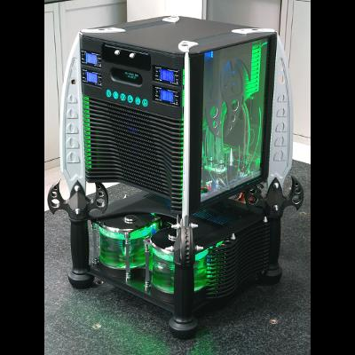](https://www.forbes.com/pictures/54f4e708da47a54de82449f8/the-20-most-amazing-pc-mo/)](https://www.forbes.com/pictures/54f4e708da47a54de82449f8/the-20-most-amazing-pc-mo/" \t "_self)

[Gallery](https://www.forbes.com/pictures/54f4e708da47a54de82449f8/the-20-most-amazing-pc-mo/" \t "_self)

[The 20 Most Amazing PC Mods Ever Made](https://www.forbes.com/pictures/54f4e708da47a54de82449f8/the-20-most-amazing-pc-mo/" \t "_self)

[20 images](https://www.forbes.com/pictures/54f4e708da47a54de82449f8/the-20-most-amazing-pc-mo/" \t "_self)